Application for Patient Research Partners Bursary ICTMC 2026

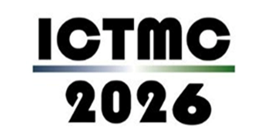

Please complete the application form and return to Kerrie McGiveron, kerrie.mcgiveron@liverpool.ac.uk by Thursday 28th May 2026. We will use the information supplied in this application form to select and notify successful applicants by Friday 26th June 2026.

Forename

Surname

Email address

Address & Postcode

Telephone number

Please tell us a little about your experience of involvement in clinical trials in particular your role as a public contributor. E.g. have you been involved in helping a research team design, develop and deliver their study)? (maximum 200 words)

From your perspective, why is the way we design and deliver clinical trials important? Please mention any examples where you have been involved in discussing or deciding Methodology issues, or any particular Methodology issues you wish to explore at this conference. (maximum 200 words)

What do you hope to contribute to and gain from the conference, and how will you share any contributions or learning with other public partners who are involved in designing and delivering clinical trials? (maximum 200 words)

